Build an artificial neural network by implementing the backpropagation algorithm and test the same using the appropriate datasets.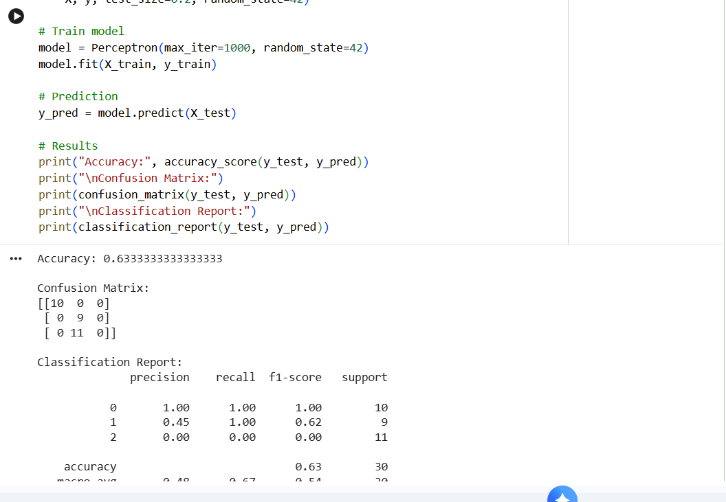

Implement perceptron based IRIS classification
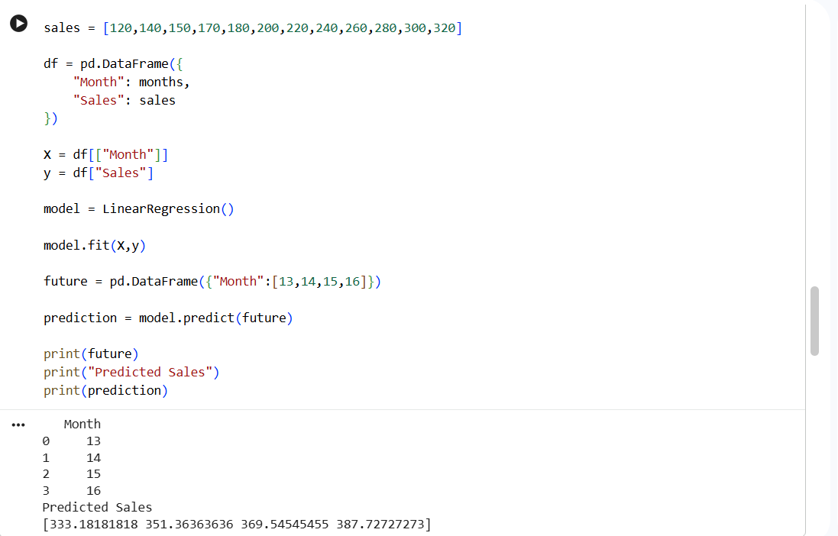
Implement future sales prediction using suitable machine learning algorithm
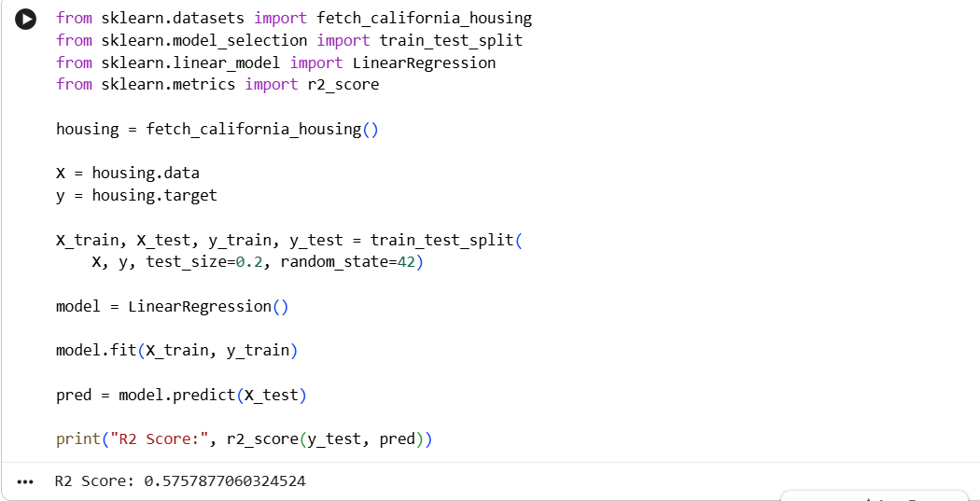

Implement house price prediction using a appropriate machine learning algorithm
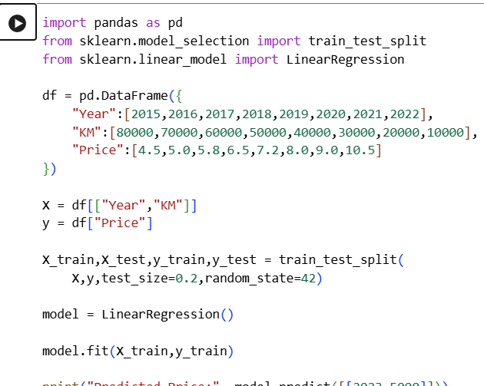

Implement the car price prediction model using python
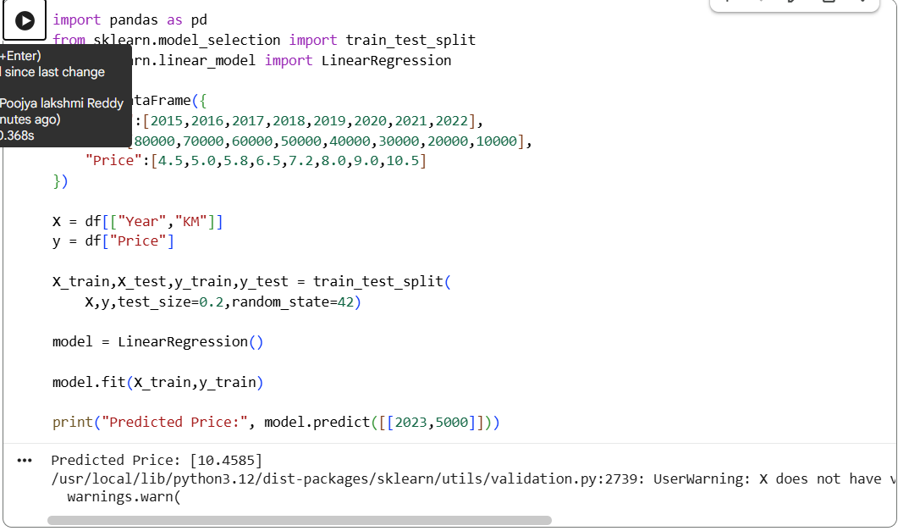

To implement Naïve Bayes algorithm in Python and display the result using confusion matrix
and accuracy.
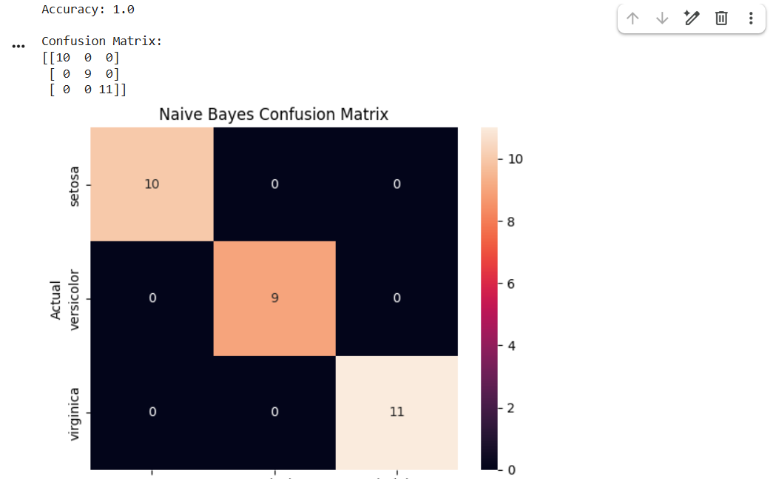

To implement and compare Linear Regression and Polynomial Regression using Python.
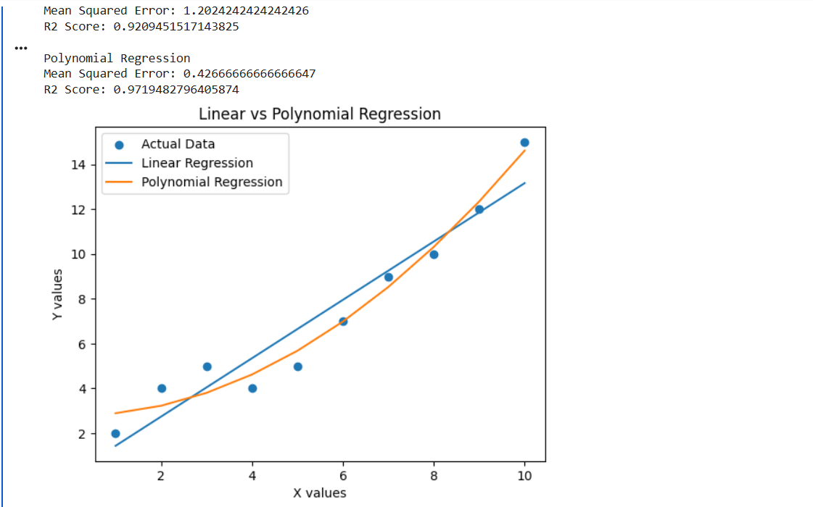

To implement the Expectation Maximization algorithm in Python using Gaussian Mixture
Model.
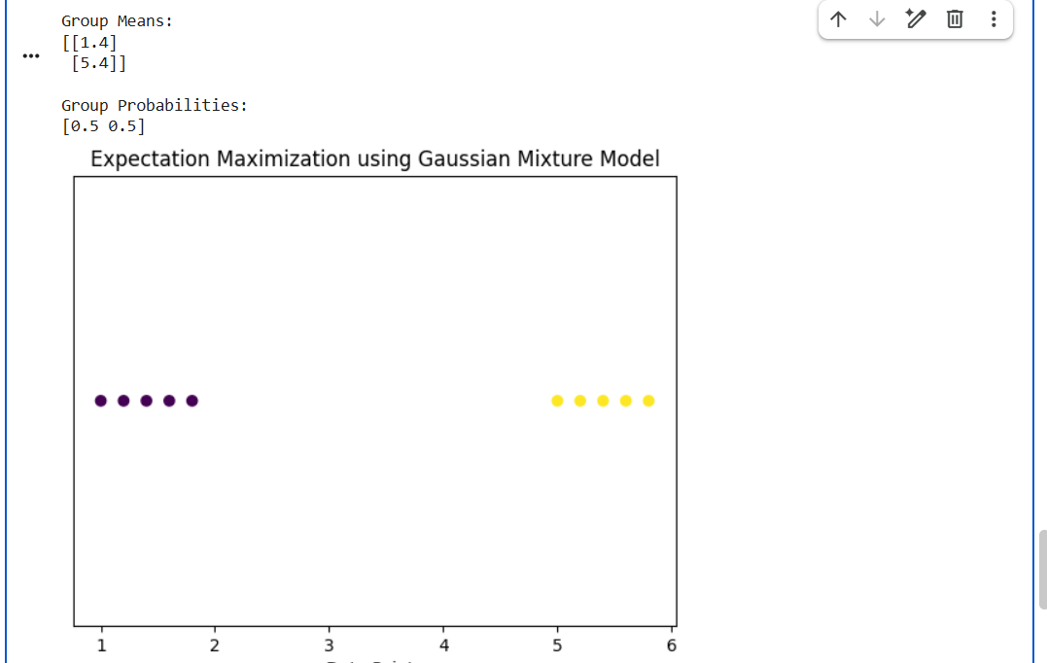
To implement a machine learning program for Credit Score Classification.
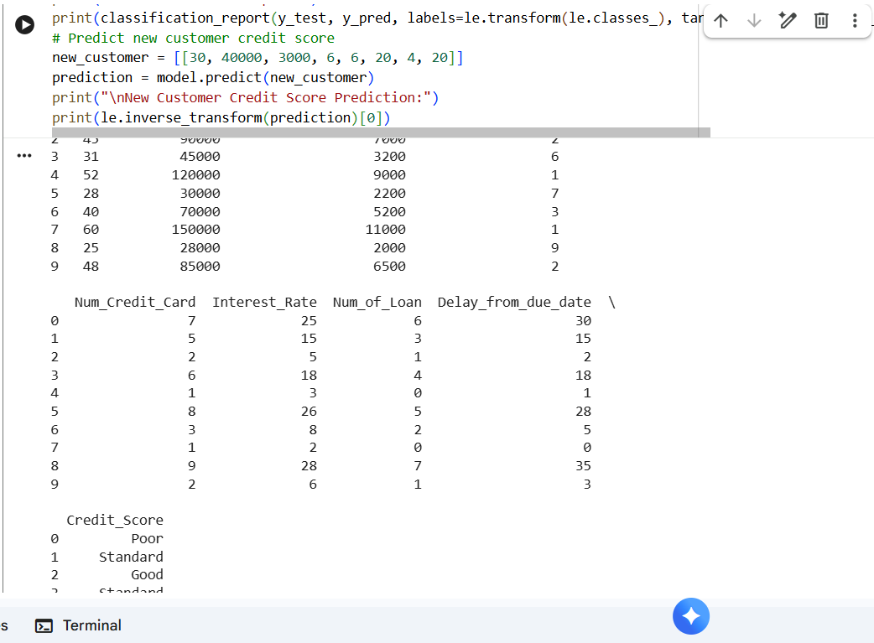

To implement Iris Flower Classification using the K-Nearest Neighbours (KNN) algorithm.
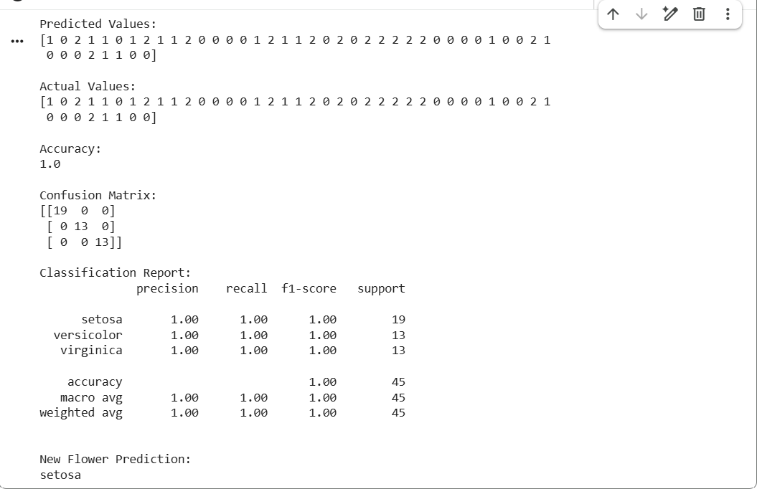

To implement a Car Price Prediction Model using Python.
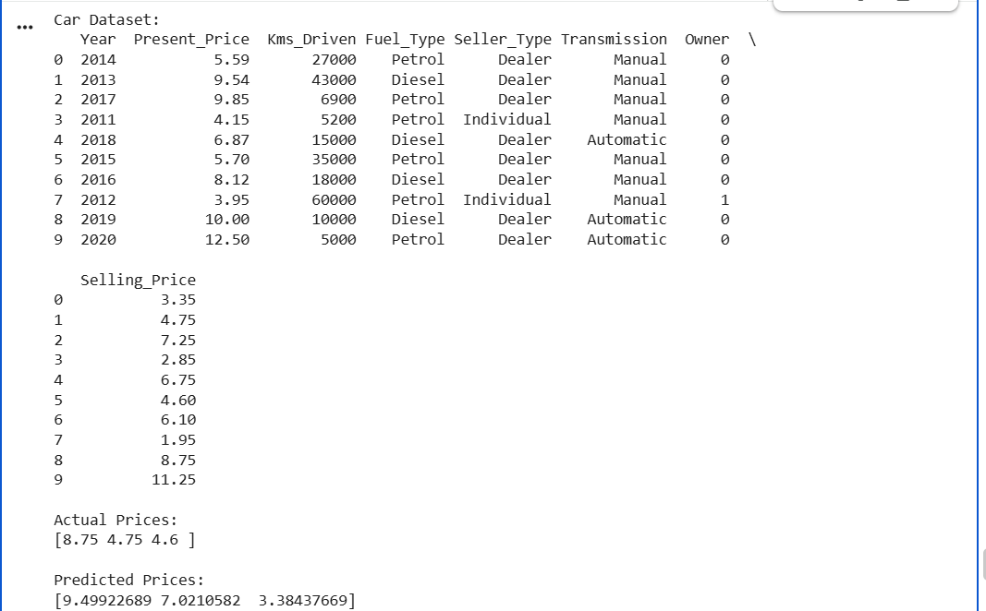

To implement Iris Flower Classification using the Naive Bayes classifier.
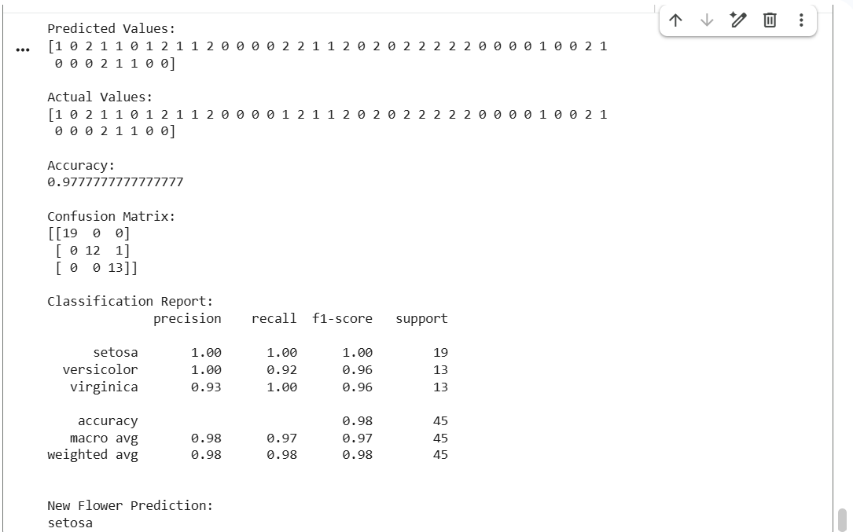

To compare different classification algorithms and evaluate their performance using Accuracy,
Precision, Recall, F1-Score, and Confusion Matrix.
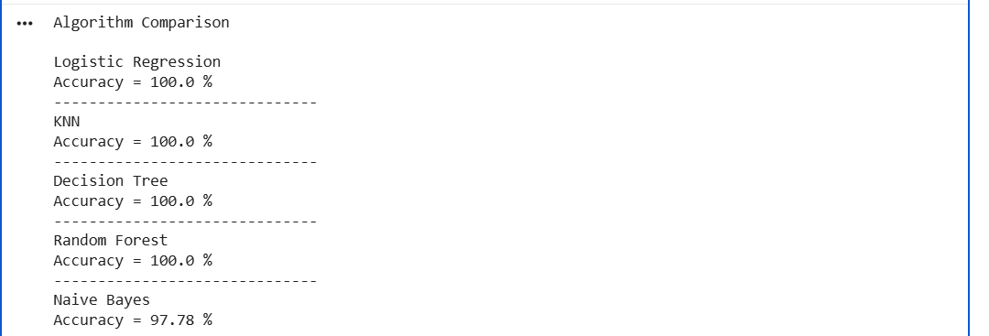

To implement Mobile Price Prediction using an appropriate machine learning algorithm.

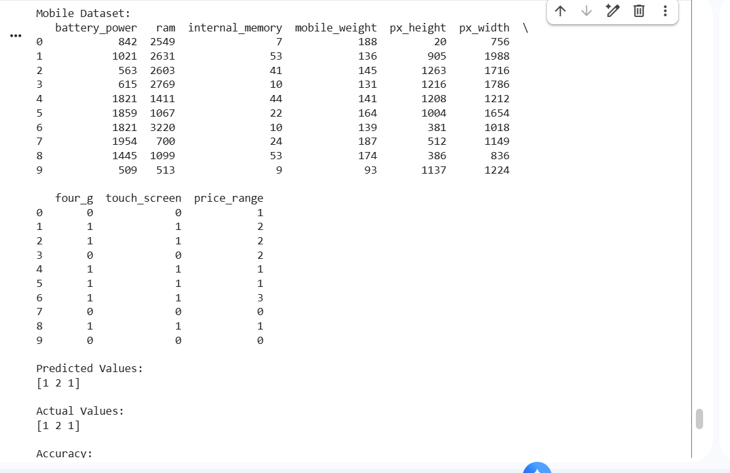

To implement Iris flower classification using the Perceptron algorithm.
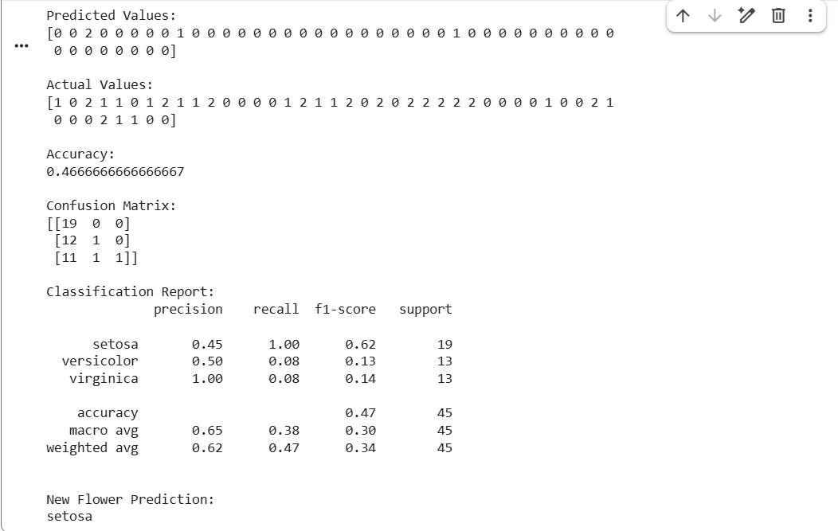

To implement Naive Bayes classification for predicting whether a bank loan will be approved or
not.

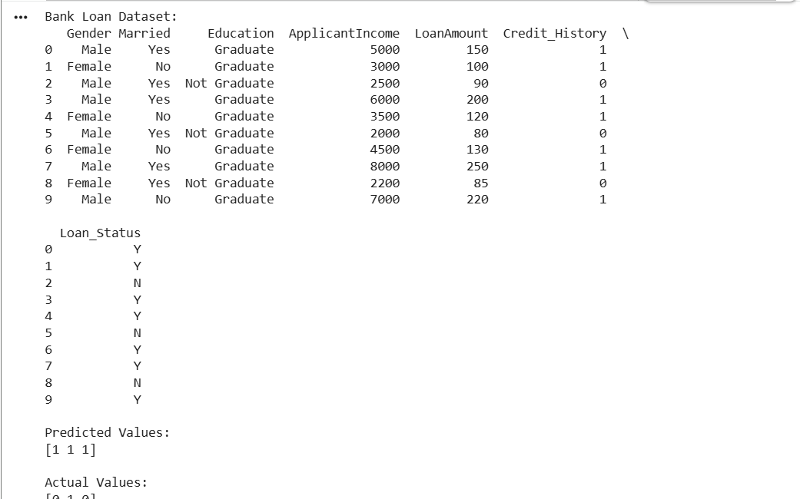
To implement Future Sales Prediction using a suitable machine learning algorithm (Linear
Regression).

